Psychology 301 Cognitive Neuroscience Fall 2024

# Course Description & Objectives:

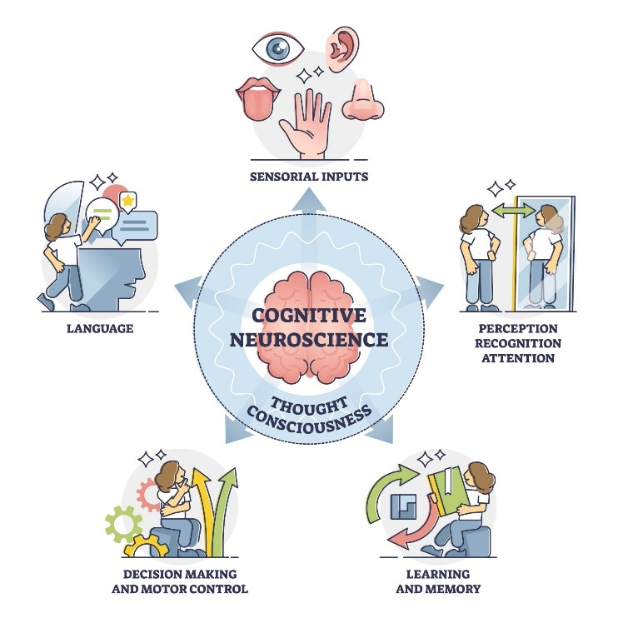The goal of this course is to introduce ideas of how human behavior is linked with what is happening in the brain. Cognitive neuroscience continues to be a “hot” field and there is much enthusiasm about the applications of this research. This is evidenced by the regularity with which articles appear on this topic in the popular press. For example, Pixar released “Inside Out” and “Inside Out 2”, set inside the brain of a teenage girl. Reporting in the neurosciences is particularly prone to sensationalism and misinformation (Illes, 2010). Understanding the intricacies of cognitive neuroscience will help you to evaluate claims made by the media and policymakers concerning the applications of this kind of research. Can we detect if someone is lying using fMRI? Should students learning math be banned from using calculators in class because their frontal lobes are not active when they do so? These questions are of interest to society at large because they have implications for criminology, education, advertising, etc… After completing this course, you will have a basic understanding of neuroscientific methods, the anatomy of the brain, and how the brain gives rise to cognition, action, and emotion. This knowledge will help you to interpret for yourself how this research should be used and to what extent these findings are applicable to more wide-ranging issues.

# Course information:

# Class time: MW 10:20-11:40

# Room 118, Psychology Building

# Instructor:

Susan Ravizza

[ravizzas@msu.edu](mailto:ravizzas@msu.edu)

Office hours: W 2-3 pm (Psy 285C) and by appointment through Zoom or in person

# Graduate Teaching Assistant:

Bailey Rann

rannbail[@msu.edu](mailto:yenjodie@msu.edu)

Office hours: MW 3-4 pm

Zoom link: <https://msu.zoom.us/j/94009970528>

Meeting ID: 940 0997 0528

Passcode: 169312

# Undergraduate **Teaching** Assistant:

Christina Trate

tratechr[@msu.edu](mailto:yenjodie@msu.edu)

Office hours: T 4:30-5:30 pm and TH 10-11 am.

Zoom link: <https://msu.zoom.us/j/3849588500>

Meeting ID: 384 958 8500

Passcode: 391154

# Required reading:

Scientific articles (links posted on D2L)

# Recommended reading:

MS Gazzaniga, RB Ivry, GR Mangun. “Cognitive Neuroscience: The Biology of the Mind**”** 5th Edition (2019)

# Course grading:

**IN PERSON** Exams (3 x 20%) 60%

Blog Entry/Tweet/FB post 15%

**D2L** Quizzes (3 x 5%) 15%

Homework (20 x .05%) 10%

# Exams:

There will be three exams. Each exam will be composed of multiple choice and essay questions. **All exams will be held in our regular classroom. They will be closed-book.** There will be no final exam.

You may take a makeup exam in case of: 1) a documented medical emergency, or 2) a schedule conflict that you know about in advance such as a religious holiday or sports travel. In either case, please send an email identifying the reason for missing the exam ASAP. In case of a schedule conflict, you must send this email at least a week in advance of exam day. Do not assume I have gotten your email unless I have responded to you. Personal travel, having to go to work, or lack of planning are not acceptable reasons to receive an earlier exam time or a makeup exam time.

If granted a make-up exam, you may take the exam either at a different time on the exam day or the day after. If you cannot take the exam on one of those two days, then that exam will be omitted from your final score and its points distributed over the other exams. If you miss an exam for any other reason or don’t notify me about your emergency or conflict, your score will be 0.

# Blog Entry/Tweet/FB post

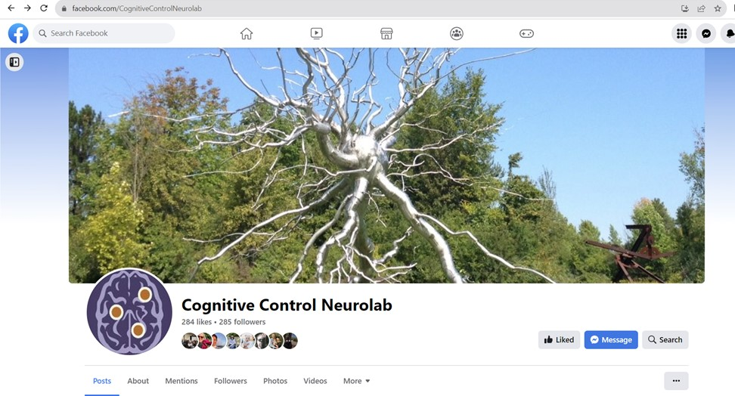One of my educational goals is to use social media to inform the general public about cognitive neuroscience research. I post content about my research through my lab blog (ravizzalab.wordpress.com) and Facebook page (Cognitive Control Neurolab). Every week, 10-12 students (chosen randomly) will write a blog entry about a recent finding in cognitive neuroscience that describes the finding and gives the student’s opinion. See D2L for more information.We will pick the best of the bunch each week and post the blog and FB post on the Internet (anonymously if the winner prefers).

The list of due dates will be posted on D2L and the first blog will be due **Friday, September 13**. Blog entries should be uploaded to D2L in the appropriate dropbox. Late blogs will be penalized 1 point for every day they are late. Please put your due date in your calendar - you will receive no reminders about when it is due!

# Homework

Lecture slides present graphs and figures from cognitive neuroscience experiments. To help students process this complex information, homework will focus on acquiring a deeper understanding of the material in the slides. There will be 1-2 homework assignments each week – one for each lecture that week – for a total of 21 homework assignments. I will only count 20 of the 21 assignments with each assignment worth 1/2 of a percentage point (20 x .5% = 10%). I will not accept late homework. Homework can be accessed through D2L each Monday and will be due by Sunday at 11:59 pm of that week. Homework will be graded on completion rather than accuracy and can be found in the Quizzes section on D2L. Homeworks 1 and 2 are due September 1.

# D2L Quizzes

Quizzes are meant to help you to discover what you don’t know, so that when you come to the review session, you can ask questions. Each quiz will be open 3 days before the review session and will be due at midnight the day before the review session. Quizzes will be open book. All quizzes will be held via D2L and thus the course requires access to high-speed internet.

# Extra credit

If you would like to obtain extra credit, you can comment on the blogs posted on ravizzalab.wordpress.com. You can make up to two comments – each worth 1% of your grade. The comments should be on two different blogs. Comments should be substantive and not just say “nice job”. Comments also need to be polite!Your comment will not show up immediately on the blog because I have to approve it. All comments need to be made by December 8 to receive credit.

# A+ Students | Toronto ONGrading scale:

90% and above = 4.0

85% - 89.9% = 3.5

80% - 84.9% = 3.0

75% - 79.9% = 2.5

70% - 74.9% = 2.0

65% - 69.9% = 1.5

60% - 64.9% = 1.0

59.9% and below = 0.0

# Class schedule

|  |  |  |  |
| --- | --- | --- | --- |
| **Lecture** | **Date** | **Topic** | **Readings** |
| **1** | 8/26/2024 | What is cognitive neuroscience and what isn’t it? |  |
| **2** | 8/28/2024 | Why do we need to know about neurons? | #1 Father of Modern Neuroscience |
|  | 9/2/2024 | **Labor day Holiday** |  |
| **3** | 9/4/2024 | How do we know what the brain is doing? |  |
| **4** | 9/9/2024 | How do we know what the brain is doing? | #2 A stimulating solution to smoking |
| **5** | 9/11/2024 | What is a perceptual hierarchy? |  |
| **6** | 9/16/2024 | What is a distributed object representation? |  |
| **7** | 9/18/2024 | Are faces processed uniquely? | #3 How the brain reads faces |
|  | 9/23/2024 | Catch up/Review session |  |
|  | 9/25/2024 | Exam 1 – In-class |  |
| **8** | 9/30/2024 | How does the brain enhance perception of attended information? | #4 The brain-boosting power of video games |
| **9** | 10/2/2024 | Is unattended information represented in the brain? |  |
| **10** | 10/7/2024 | Is movement a cognitive process? |  |
| **11** | 10/9/2024 | How does the brain make it possible to play tennis or volleyball? | #5 Chimpanzees use social information to acquire a skill |
| **12** | 10/14/2024 | Why are we talking so much about movement?!?$%! |  |
| **13** | 10/16/2024 | How do our brains store so much information? | #6 Sleep Healing |
|  | 10/21/2024 | **Fall Break** |  |
| **14** | 10/23/2024 | Why do amnesiacs remember how to write? |  |
|  | 10/28/2024 | Catch up/Review session |  |
|  | 10/30/2024 | Exam 2 – In-class |  |
| **15** | 11/4/2024 | Why are language disorders so common? | #7 How brains seamlessly switch between languages |
| **16** | 11/6/2024 | How does the brain allow people to communicate? |  |
| **17** | 11/11/2024 | Is there some truth to being a left-brained person? |  |
| **18** | 11/13/2024 | Why do I forget the reason I stood up? |  |
| **19** | 11/18/2024 | How does your brain enable you to sit in class instead of sleeping in? | #8 The prefrontal cortex: from monkey to man |
| **20** | 11/20/2024 | Why do I cry at a sad movie? |  |
| **21** | 11/25/2024 | Why don’t I Hulk out all the time? | #9 Brain waves synchronize when people interact |
|  | 11/27/2024 | **CLASS CANCELLED** |  |
|  | 12/2/2024 | Catch up/Review session |  |
|  | 12/4/2024 | Exam 3 – In-person |  |
|  | 12/13/2024 | Final exam time (7:45-9:45am) | NO final exam but I will be available for questions |

# Accommodations for Students with Disabilities:

[From the Resource Center for Persons with Disabilities](https://www.rcpd.msu.edu/get-started/faculty-departmental-resources/model-statements-disability-inclusion) (RCPD): Michigan State University is committed to providing equal opportunity for participation in all programs, services and activities. Requests for accommodations by persons with disabilities may be made by contacting the Resource Center for Persons with Disabilities at 517-884-RCPD or on the web at [rcpd.msu.edu](https://rcpd.msu.edu). Once your eligibility for an accommodation has been determined, you will be issued a Verified Individual Services Accommodation ("VISA") form. Please present this form to me at the start of the term and/or two weeks prior to the accommodation date (test, project, etc.). Requests received after this date will be honored whenever possible.

# Academic Honesty:

Article 2.III.B.2 of the [Academic Rights and Responsibilities](http://splife.studentlife.msu.edu/student-rights-and-responsibilities-at-michigan-state-university/article-2-academic-rights-and-responsibilities) states that "The student shares with the faculty the responsibility for maintaining the integrity of scholarship, grades, and professional standards." In addition, the [insert name of unit offering course] adheres to the policies on academic honesty as specified in [General Student Regulations](http://splife.studentlife.msu.edu/regulations/general-student-regulations) 1.0, Protection of Scholarship and Grades; the [all-University Policy on Integrity of Scholarship and Grades; and Ordinance 17.00, Examinations](https://ombud.msu.edu/academic-integrity/). See [Spartan Life Online](http://splife.studentlife.msu.edu/) (splife.studentlife.msu.edu) and/or the [MSU Web site](http://www.msu.edu/) (msu.edu) for more.

Therefore, unless authorized by your instructor, you are expected to complete all course assignments, including homework, lab work, quizzes, tests and exams, without assistance from any source. You are expected to develop original work for this course; therefore, you may not submit course work you completed for another course to satisfy the requirements for this course. Also, you are not authorized to use the www.allmsu.com Web site **or generative artificial intelligence (AI)** to complete any course work in this course. Students who violate MSU academic integrity rules may receive a penalty grade, including a failing grade on the assignment or in the course. Contact your instructor if you are unsure about the appropriateness of your course work. (See also the [Academic Integrity webpage](https://ombud.msu.edu/academic-integrity/).)

# Limits to Confidentiality:

Essays, journals, and other materials submitted for this class are generally considered confidential pursuant to the University's student record policies. However, students should be aware that University employees, including instructors, may not be able to maintain confidentiality when it conflicts with their responsibility to report certain issues to protect the health and safety of MSU community members and others. As the instructor, I must report the following information to other University offices (including the Department of Police and Public Safety) if you share it with me:

* Suspected child abuse/neglect, even if this maltreatment happened when you were a child,
* Allegations of sexual assault or sexual harassment when they involve MSU students, faculty, or staff, and
* Credible threats of harm to oneself or to others.

These reports may trigger contact from a campus official who will want to talk with you about the incident that you have shared. In almost all cases, it will be your decision whether you wish to speak with that individual. If you would like to talk about these events in a more confidential setting you are encouraged to make an appointment with the MSU Counseling Center.

# Disruptive Behavior:

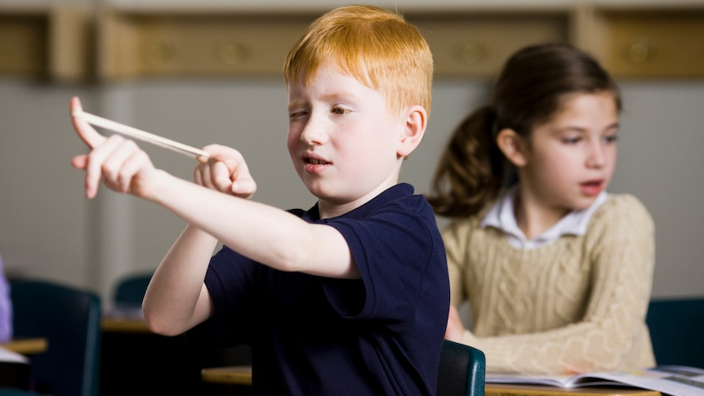Article 2.III.B.4 of [Student Rights and Responsibilities](http://splife.studentlife.msu.edu/student-rights-and-responsibilities-at-michigan-state-university/article-2-academic-rights-and-responsibilities) for students at Michigan State University states: "The student's behavior in the classroom shall be conducive to the teaching and learning process for all concerned." Article 2.III.B.10 states that "The student and the faculty share the responsibility for maintaining professional relationships based on mutual trust and civility." [General Student Regulation 5.02](http://splife.studentlife.msu.edu/regulations/general-student-regulations) states: "No student shall . . . obstruct, disrupt, or interfere with the functions, services, or directives of the University, its offices, or its employees (e.g., classes, social, cultural, and athletic events, computing services, registration, housing and food services, governance meetings, and hearings).” Students whose conduct adversely affects the learning environment may be subject to disciplinary action through the Student Judicial Affairs office.

